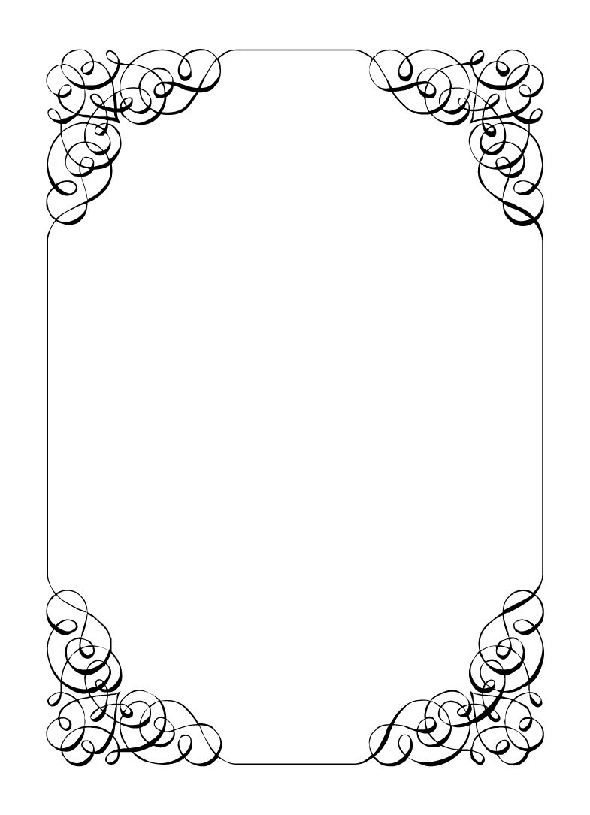

Not here to wed spiders

Mercedes Bennie

*In the small town of Duck Rise, Victoria, Stralya live: BOGANS. Bogans are much like the regular folk, but drunker and louder. Some of them even fall in love. But before they settle down and poop out a mess of kids, they gotta have a wedding! Weddings are the best. Everyone gets proper plastered. Lots of kissing. Lots of drama. Fun times for all. Nothing ever goes wrong at a wedding...*  
*\*\*ominous thunder clack\*\**

Mercedes Bennie

Flowergirl *Anarchist, Moody, Cynical Teenager*

There are two kinds of people in this world. Rubes and You. (Takes a long drag of the cigarette) 😎. You might be 12 years old, but you've lived longer and harder than anybody you know.  
You have to be here, but maybe you can make it worth your while.  
  
Last Night: You were at the bachelorette party. It was you, Gemini, Corolla, Vectra, and Mungo. You were too young to be there, but someone had to make it a real party. You gave Gemini a small dose of Ketamine and she took it hard. Oops. You weren't allowed in the Casino, so you left and made a few sales. Everyone else was too drunk to care that you bailed.

**Goals**

* **Get out of this horror show:** Get uninvited from the wedding, this dress is not your style. If you can't get uninvited at least sigh everytime it takes longer because of an interuption.
* **Find a reason Corolla can't marry:** She has to have some skeletons in her closet. You certainly do at this age.
* **Sabotage Gemini's every move:** She tried to have you taken away, and you ended up on the streets. Now she is gonna pay.
* **End the wedding with as much valuables as possible:** Sell some drugs. Sparkie never pays, it's now $1000 a hit for that loser. Perhaps someone else will buy?
* **Catch the bouquet and smash it on the ground:** It would ruin everyone's fun.

**Other People**

**Chad Marolla**

Classic choice for your foster sister. Thick as a brick, with a matching personality.

**Corolla Castro**

You can't believe your foster sister is making you go to this gag worthy wedding. She has no taste. She never wanted you as a sister, time to show her why.

**Gemini Belmont**

She used to be your babysitter, then when she left for police academy. Your parents couldn't handle you, got drunk and then died in a car crash. Why did she leave, why would she let them die like that!

**Robin Smith**

You know police when you see one and Robin is just square enough to be an undercover cop.

**Dave Torana**

You have seen Dave at the one local night club (Barrels) a few times, never with anyone though.

**Malibu Singer**

Often visited Corolla when Gemini was away. Didn't take up your offer to 'cater' for the wedding. Shame.

**Sparkie Castro**

He fostered you when your parents died. He is so vacant he might of well have not bothered. He is the closest thing you have to parent now, you just wish he would stop buying your supply...

**Vectra Marolla**

She looks like a doll all dressed up but you can't deny she knows how to kick ass and get things done. She must be hella loaded...

**Wayne Marolla**

He looks grubby, but has a head on his shoulders. You reckon he must be running some kind of con. Game recognise Game yo.

**Lucky the Wonder Dog**

You are more of a cat person. You wonder what kinda tricks they would do with a little pick me up.

**Mungo Joint**

A little too eager with the camera. You've had to dive outta the way of some shots earlier. What a nark.

**Abilities**

Use these to do things. They have a limited use, so check them off when you use them.

|  |  |
| --- | --- |
| Ability | We have ways of making you talk |
| If someone is intoxicated, show them this ability. The player must show you their secret or information: your choice. |
| Usages: O O O |

|  |  |
| --- | --- |
| Ability | You can't do that with a child here! |
| If someone uses an ability on you or someone else while you are watching, show this ability to them and their ability fails. |
| Usages: O O |

|  |  |
| --- | --- |
| Ability | Secret stash |
| Talk to an Organiser and get some more drugs from you stash. |
| Usages: O O O |

|  |  |
| --- | --- |
| Ability | Swapsy |
| Offer drugs to another player and name an item. If they have that item on them, they must swap it for the drugs. If they do not have the item, this still uses a charge. |
| Usages: O O |

**Secret and Information**

Your Secret contains your guilty secret, while your Information contains one or more items of information you know. Both may be affected by abilities. Your lie may need to be filled out later.

While you can show your Secret and Information to whomever you like, you will probably not want to reveal your Secret too often. (Please note that you can’t solve the crime by looking at everyone’s Secret and Information – it’s not that easy!)

|  |  |
| --- | --- |
| Secret | I run the entire town's drug trade. |

|  |  |
| --- | --- |
| Information | I saw Gemini trying on the wedding ring at the bachelorette party. |

**The Organiser’s Word is Law:** The organisers are impartial. If you have a problem or want to do something unusual, see an organiser. The organiser’s power is absolute – and cannot be affected by ability cards!

**Winning and Losing:** You can achieve most of your goals simply by talking to people. The organisers will announce when the game is over. If you haven’t succeeded by that point – you’re too late! Be warned – not everyone here will want you to succeed!

**Doing Stuff:** Ordinary actions are resolved by simply carrying them out. If you want to try something unusual (such as trying to hack the pentagon), see an organiser. The organisers knows everything – and will be able to tell you the outcome of whatever it is that you are trying to do. (For example, you are trying to hack over state lines and you are caught.) Do use your imagination, though! – this is a very flexible game, and you can do all sorts of things beyond what’s listed in these rules.

**Fighting:** If an ability or item lets you hard another player, don’t just dive in! See the organisers first and tell them what you plan to do so they can oversee and give you more detailed rules if it’s necessary.

**Leaving:** You cannot leave, it is rude to leave a wedding and you are in the middle of nowhere!

**Role Cards:** If someone asks you for your role in the wedding ceremony, and you have one, you must show them all your roles.

**Item Cards:** Any items of importance within the game are represented as Item cards – and the only items that can affect the game are those detailed on the cards. If you do not have an Item card, you do not have that item with you.

**Time:** This game is played over three (ish) hours, including time for reading your character etc. There will be breaks throughout the evening! The organisers will tell you when each period starts and finishes.

**Character List**

**Chad Marolla – *Groom***

The soon to be husband. A bit nervous about the wedding, but is letting Corolla take care of the hard stuff.

**Corolla Castro – *Bride***

She knows what kind of wedding she wants, and that's the kind of wedding we are having! NO EXCEPTIONS!

**Gemini Belmont – *Maid of Honour***

She carries herself like she just escaped a warzone. Maybe she did? She's real quiet and might throat punch you if you ask stupid questions.

**Mercedes Bennie – *Flowergirl***

She's 12 but everyone knows better than to treat her like a 12 year old. Punk AF and will burn this all down on a whim.

**Robin Smith – *Priest***

Not from here. Better than everyone else (or at least thinks so).

**Dave Torana – *Best Man***

Childhood friends with the Groom. He was the smooth talking hottie that picked up enough for both of them. But that part of his life is over now.

**Malibu Singer – *Wedding Planner***

For a professional organiser, not very organised. Has just managed to keep everything running so far.

**Sparkie Castro – *Bride's Father***

He's been waiting his whole life for this moment. His baby girl is finally gonna get married and he knows just how to get through the day without crying...

**Vectra Marolla – *Groom's Mother***

The Queen that runs this town. Knows where the bodies are buried, but will never tell. Everyone respects her.

**Wayne Marolla – *Drunk Uncle***

He's maybe had a few too many. Started stumbling around and saying weird things. Every wedding has one.

**Lucky the Wonder Dog – *Dog***

A good dog. *bark* *bark* "What's that Lucky? You want pats?"

**Mungo Joint – *Photographer***

Seems like they are creeping on everyone, but they were hired to take wedding photos so it's probably fine.